**Dataset Analysis Report #1**

**HG Insights CRM Market Share Report**

**Link**: <https://hginsights.com/market-reports/crm-market-share-report>

**Key Insights**

**Market Dominance** -- $53 billion global CRM market -- 37% controlled by US companies -- Enterprise-heavy spending patterns

**Company Size Gap** -- 73.8% of spending from 1000+ employee companies -- Small businesses (53.9% of buyers) contribute only 0.5% of revenue -- Clear enterprise vs SME divide

**Industry Concentration** -- Finance & Insurance leads at $18.3B (34.5% market share) -- Government sector $7.9B spending -- Professional services distributed across 1.4M buyers

**Regional Patterns** -- Americas dominate with $22.5B (42.4%) -- Asia-Pacific growing at $17.8B (33.5%) -- Europe trailing at $12.7B (24.1%)

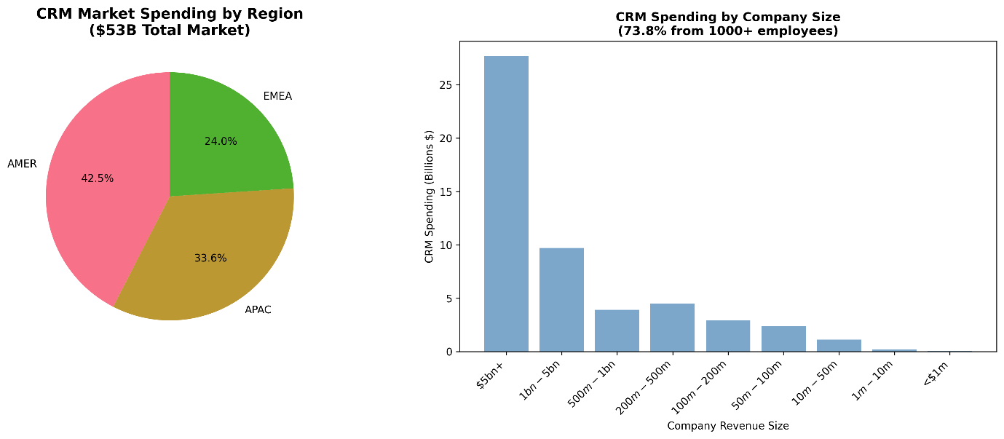

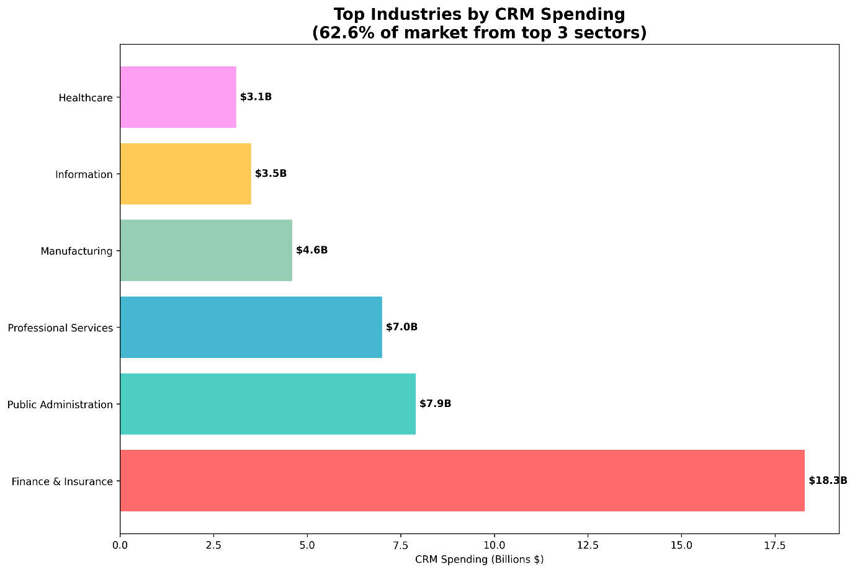

**What It Means for Us**

**B2B Context Validation** -- Enterprise software spending heavily concentrated in large organizations -- IT department budgets drive purchasing decisions -- End users (marketing/sales/finance) have minimal influence on selection

**Scale of Problem** -- $53B market represents massive user base experiencing poor UI/UX -- Financial services and government sectors most affected -- These industries notoriously struggle with user-friendly software

**Buyer-User Disconnect Evidence** -- Large enterprises make bulk purchases based on features, not usability -- 73.8% spending concentration shows IT-driven procurement -- Small businesses with direct user involvement spend proportionally less

**Research Opportunity** -- Focus on Finance & Insurance ($18.3B) and Professional Services sectors -- Target enterprise organizations with 1000+ employees -- Analyze how CRM selection process ignores end-user experience

**Dataset Analysis Report #2**

**Mendeley UI/UX User Interaction Dataset**

**Link**: <https://data.mendeley.com/datasets/dxthxmnkhx>

**Key Insights**

**User Experience Gaps** -- Loading speed rated lowest at 5.8/10 -- Mobile responsiveness struggles at 6.4/10 -- Form usability poor at 6.2/10 -- Accessibility severely lacking at 5.9/10

**Satisfaction Patterns** -- Color schemes perform best at 7.8/10 -- Scrolling/gestures rate high at 7.3/10 -- Layout design solid at 7.5/10 -- Visual hierarchy acceptable at 7.2/10

**Platform Preferences** -- YouTube dominates at 30% preference -- Twitter follows at 25% -- Facebook declining at 20% -- Traditional websites only 15%

**Critical Pain Points** -- Performance issues top user complaints -- Accessibility ignored by designers -- Mobile experience consistently poor -- Form interactions frustrate users

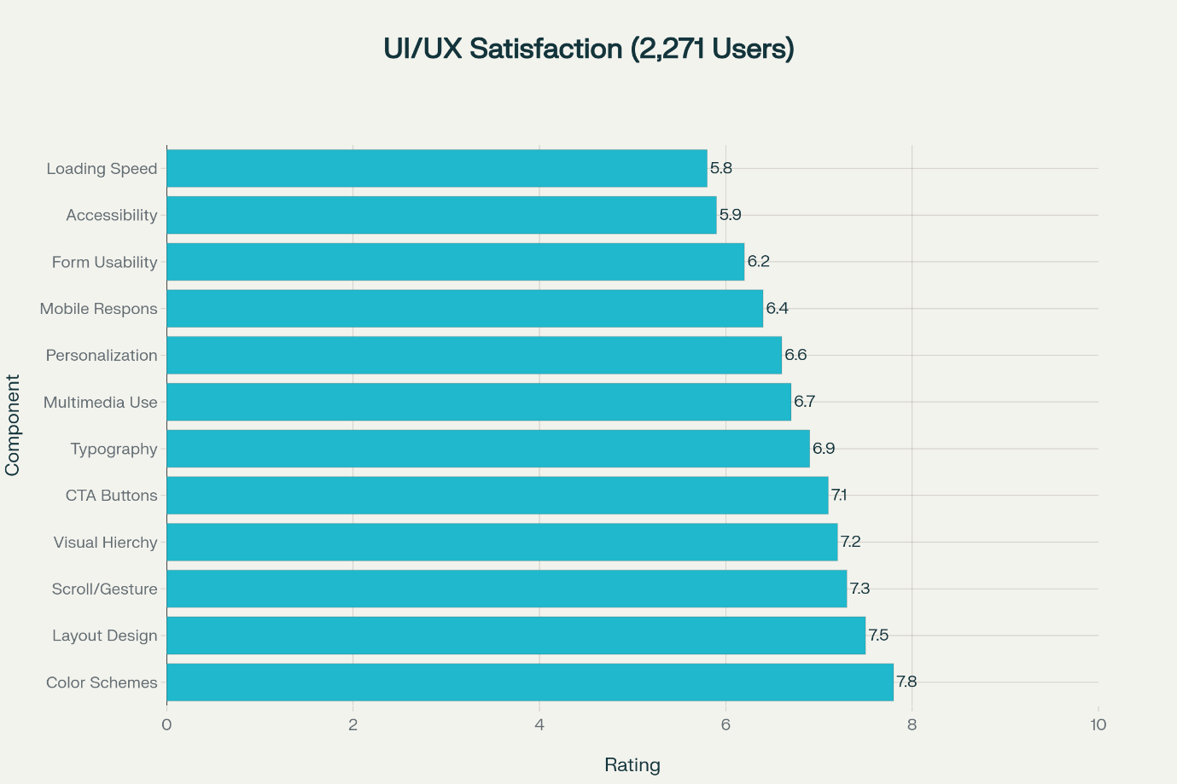

**What It Means for Us**

**Enterprise Software Reality Check** -- Consumer platforms (YouTube/Twitter) set user expectations -- Enterprise software fails on basic metrics (loading, forms, mobile) -- 2,271 users show clear preferences for intuitive design

**B2B UX Problems Identified** -- Loading speed (5.8/10) directly impacts productivity -- Form usability (6.2/10) affects daily workflows -- Mobile responsiveness (6.4/10) hurts remote work efficiency

**Consumer vs Enterprise Gap** -- Users rate consumer platforms higher -- Enterprise tools lag in performance and usability -- Consumerization expectations not met in B2B software

**Design Priority Insights** -- Focus on performance optimization first -- Improve form design for B2B workflows -- Enhance mobile responsiveness for hybrid work -- Address accessibility for compliance and inclusion

**Dataset Analysis Report #3**

**Stack Overflow 2025 Developer Survey**

**Link**: <https://stackoverflow.co/company/press/archive/stack-overflow-2025-developer-survey/>

**Key Insights**

**AI Tool Adoption** -- 84% developers use or plan to use AI tools -- 46% don't trust AI accuracy (up from 31% in 2024) -- 45% find debugging AI code time-consuming -- Trust varies dramatically by country

**Developer Tool Preferences** -- Visual Studio Code remains dominant IDE -- Docker usage jumped 17% to 71% adoption -- PostgreSQL leads database preferences -- GitHub dominates collaboration (81%)

**Learning Patterns** -- 69% learned new coding techniques last year -- 44% use AI tools for learning (up from 37%) -- Technical documentation still preferred (68%) -- Stack Overflow remains crucial (51%)

**Geographic Trust Patterns** -- India shows highest AI trust (56%) -- Germany shows lowest trust (22%) -- Ukraine surprisingly high at 41% -- Western countries more skeptical

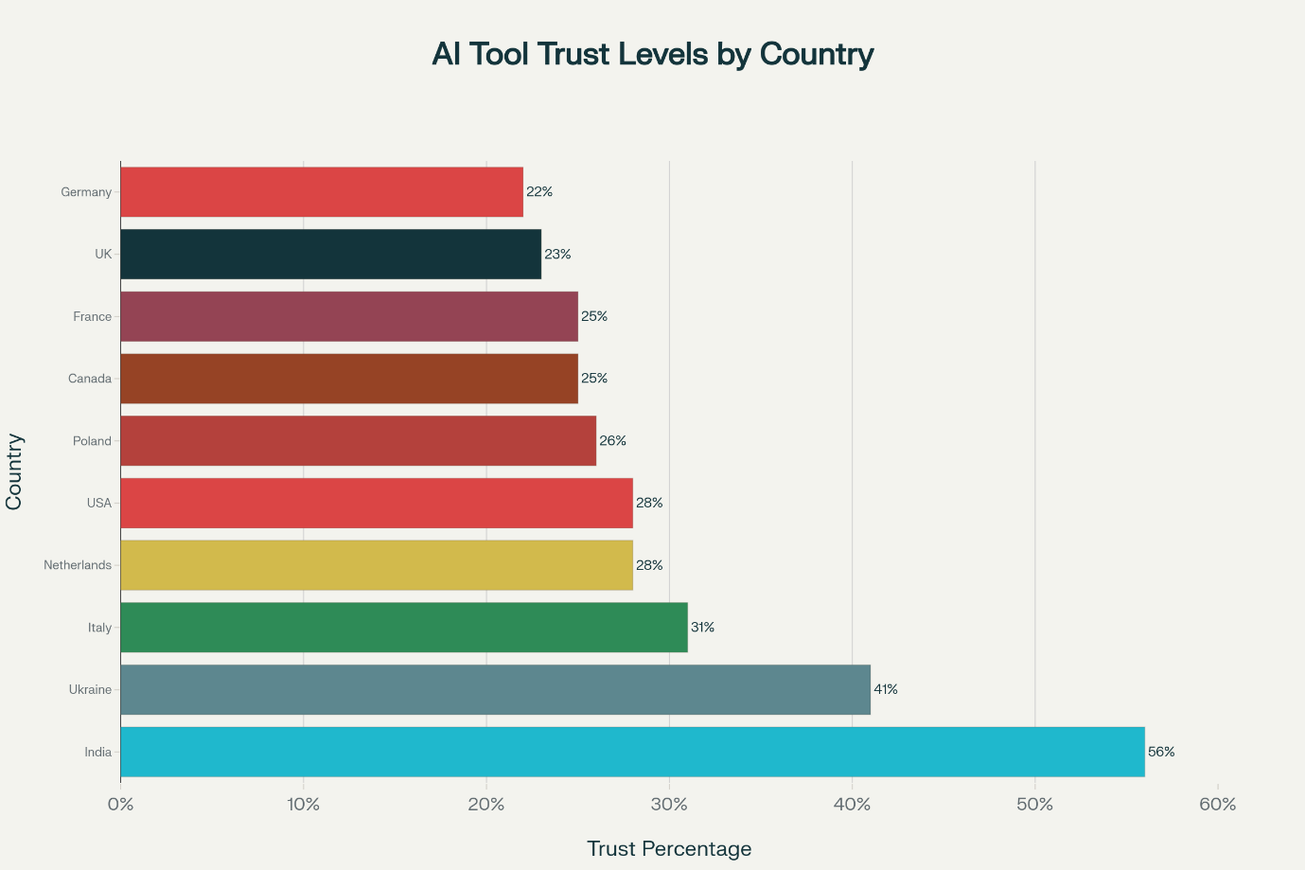

**What It Means for Us**

**Developer as Enterprise User** -- 49,000+ developers represent key B2B software users -- They experience enterprise tools daily -- Their preferences influence broader UI/UX trends -- High technical standards for usability

**Trust and Usability Connection** -- Declining AI trust (46%) shows importance of reliable UI/UX -- Debugging issues highlight poor user experience design -- Tool adoption based on perceived reliability and ease of use

**Enterprise Software Implications** -- Developers choose tools based on usability (VS Code dominance) -- Enterprise software must compete with consumer-grade experiences -- Geographic differences show cultural UI/UX preferences matter

**B2B Software Selection Insights** -- Technical users influence enterprise tool selection -- Trust and reliability trump features -- Documentation and community support crucial -- User experience directly impacts adoption rates

**Research Applications** -- Survey developers on enterprise software satisfaction -- Compare consumer tool preferences vs enterprise forced choices -- Analyze geographic patterns in B2B software acceptance -- Study correlation between tool trust and productivity